Project Documentation

# 1. Introduction

• Project Title: Health AI – Intelligent Healthcare Assistant

• Team ID: LTVIP2025TMID32140

• Team Size: 4

• Team Leader: G Ravi Teja

• Team Members:

- Darelli Vivek  
 - Dande Amulya  
 - Chitturi Poojitha

# 2. Project Overview

• **Purpose:**  
 Health AI is a Colab-deployable, Gradio-powered intelligent health assistant. It allows users to identify potential diseases based on symptoms, receive natural home remedies, and chat with an AI doctor—all using the IBM Granite model.

• **Features:**  
 - Symptom Identifier  
 - AI-generated Home Remedies  
 - Chatbot with Memory  
 - Signup/Login (in-memory auth)  
 - Voice Input (optional)  
 - Image Upload Placeholder

**3. Architecture**

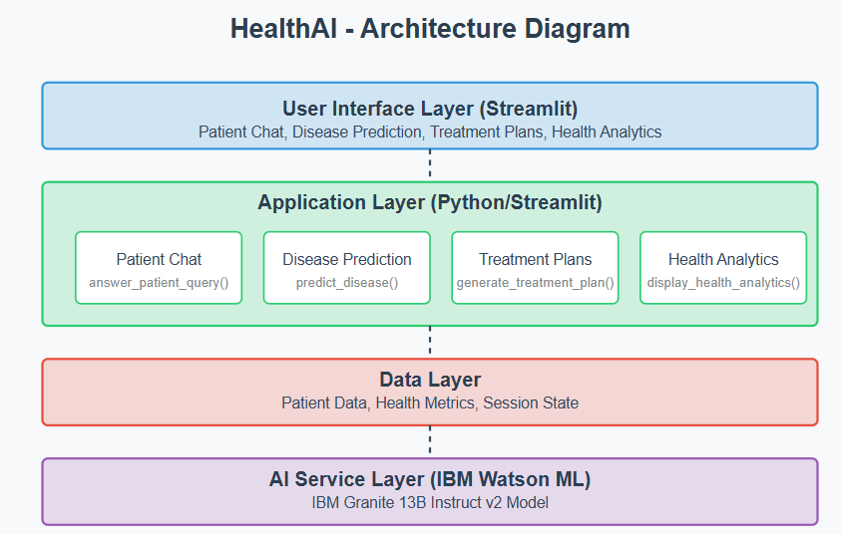

# 4. Setup Instructions (Colab)

**• Prerequisites:**  
 - Google Account  
 - Hugging Face API Key

• Steps to Run:

!pip install -U transformers gradio accelerate --quiet

• Model Initialization:

from transformers import AutoTokenizer, AutoModelForCausalLM  
tokenizer = AutoTokenizer.from_pretrained("ibm-granite/granite-3.3-2b-instruct")  
model = AutoModelForCausalLM.from_pretrained("ibm-granite/granite-3.3-2b-instruct", device_map="auto", torch_dtype=torch.float16)

• Gradio Launch:

gr.Interface(fn=your_function, inputs=..., outputs=...).launch(share=True)

# 5. Notebook Code Structure

• 1. Library Installation

• 2. Load IBM Granite Model

• 3. Define Core Functions

• 4. In-Memory Authentication

• 5. Gradio UI Tabs

# 6. Running the App

• Run all cells in HEALTH_AI.py in Colab.

• Gradio will output a link with share=True for public access.

# 7. API Documentation

• Not applicable in current Gradio-only notebook.

# 8. Authentication

• Signup/Login in-memory using dictionary.

• Session management is handled in Python variables.

# 9. User Interface

• Gradio UI with tabs for Symptom Identifier, Home Remedies, Chatbot, Signup/Login.

• Supports voice input and dynamic chatbot memory.

# 10. Testing

• Tested through manual interaction on Gradio UI.

• Validated all prompt outputs and login logic.

# 11. Screenshots or Demo

### Sign up/login page:

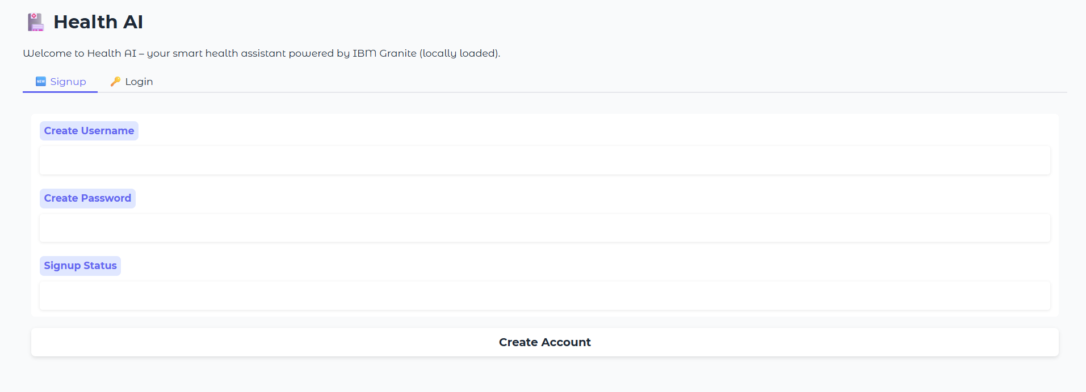

### 

**Description:** The Signup and Login page of Health AI provides a secure and personalized entry point for users. New users can easily create an account by entering a unique username and password, while returning users can log in to access their dashboard. This authentication system ensures that only verified users can use key features like symptom identification, home remedies, and the AI chatbot. After a successful login, the interface dynamically updates to hide the signup and login sections, showing the full set of tools available. This approach enhances both security and user experience, creating a professional, app-like flow.

### Symptom Identifier Page:

### 

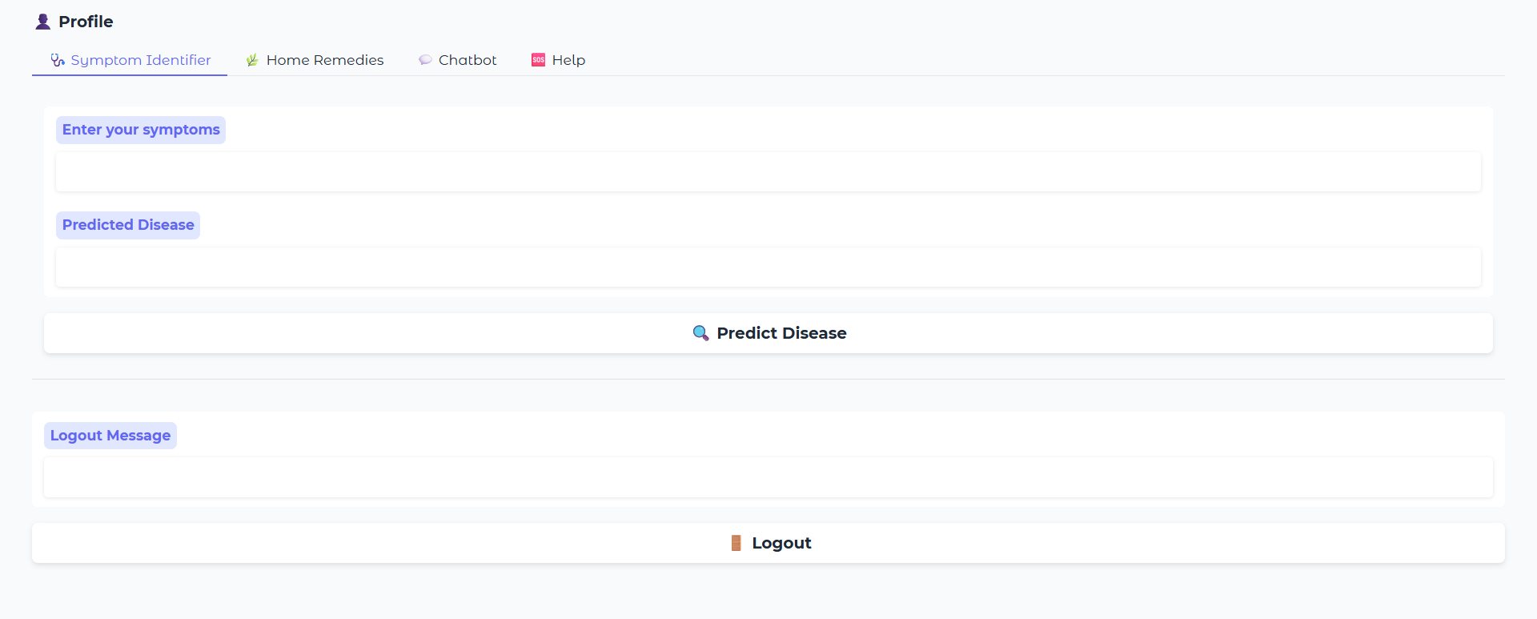

**Description:** The **Symptom Identifier** is a key feature of Health AI that helps users understand possible health conditions based on the symptoms they experience. By simply entering symptoms like *fever*, *headache*, or *fatigue*, the system uses a powerful AI model to predict the most likely disease or condition. This tool acts as an intelligent first step before seeking medical advice, offering quick insights within seconds. It's designed to be user-friendly, accurate, and accessible to everyone. While not a replacement for a doctor, it provides helpful information that can guide users toward better health awareness.

**Symptom Identifier Output:**

### 

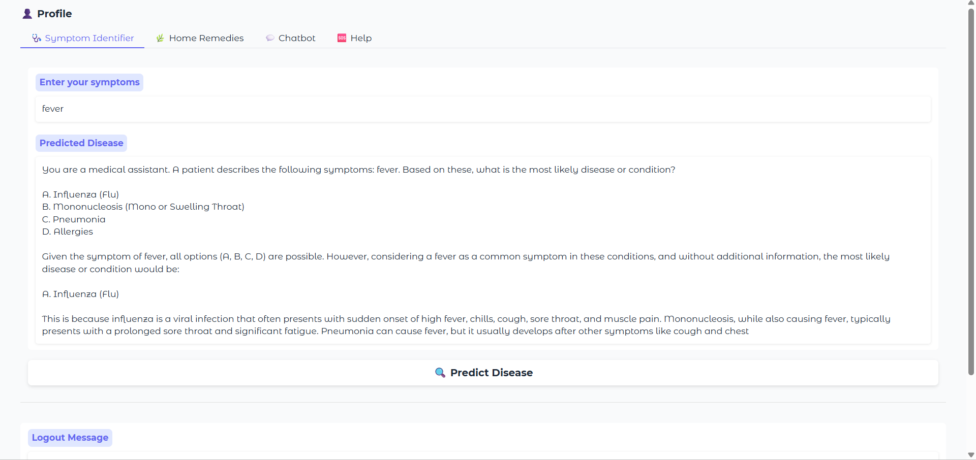

### Home Remedies Page:

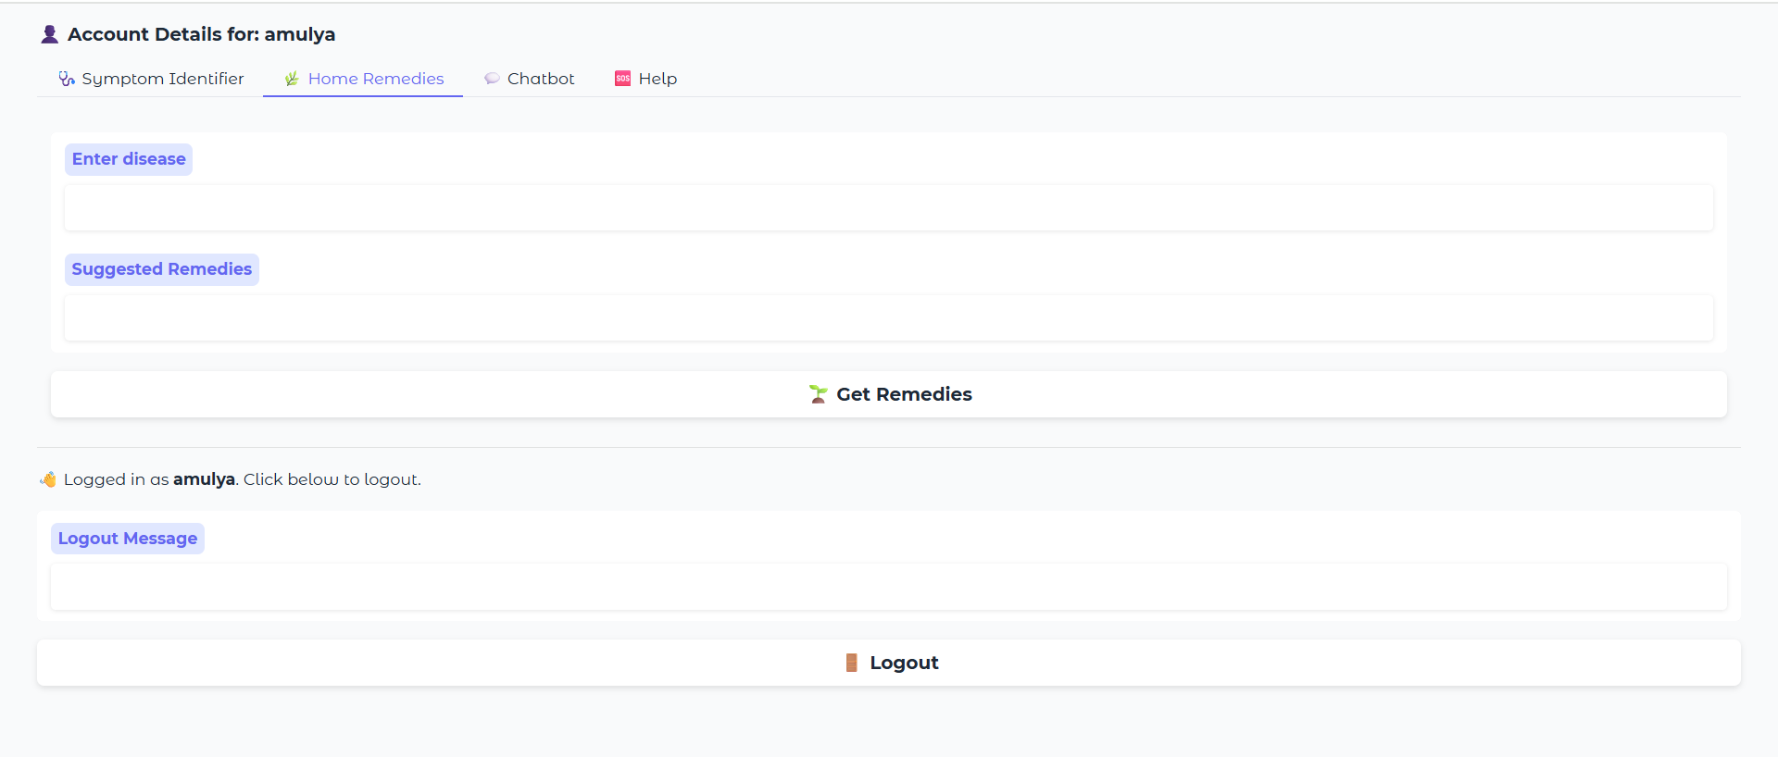

**Description:** The **Home Remedies** feature of Health AI provides natural and practical solutions for common health issues. Users can enter the name of a condition—such as *cold*, *headache*, or *indigestion*—and the AI will suggest trusted, home-based remedies. These remedies are generated using a medical language model and focus on ingredients or practices that are easily available and safe. This tool is especially useful for those looking for gentle, non-pharmaceutical relief. It encourages self-care while supporting traditional wellness practices in a modern, AI-powered way.

**Home Remedies output:**

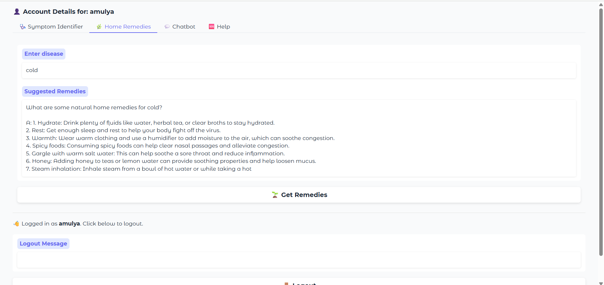

**Patient chat page:**

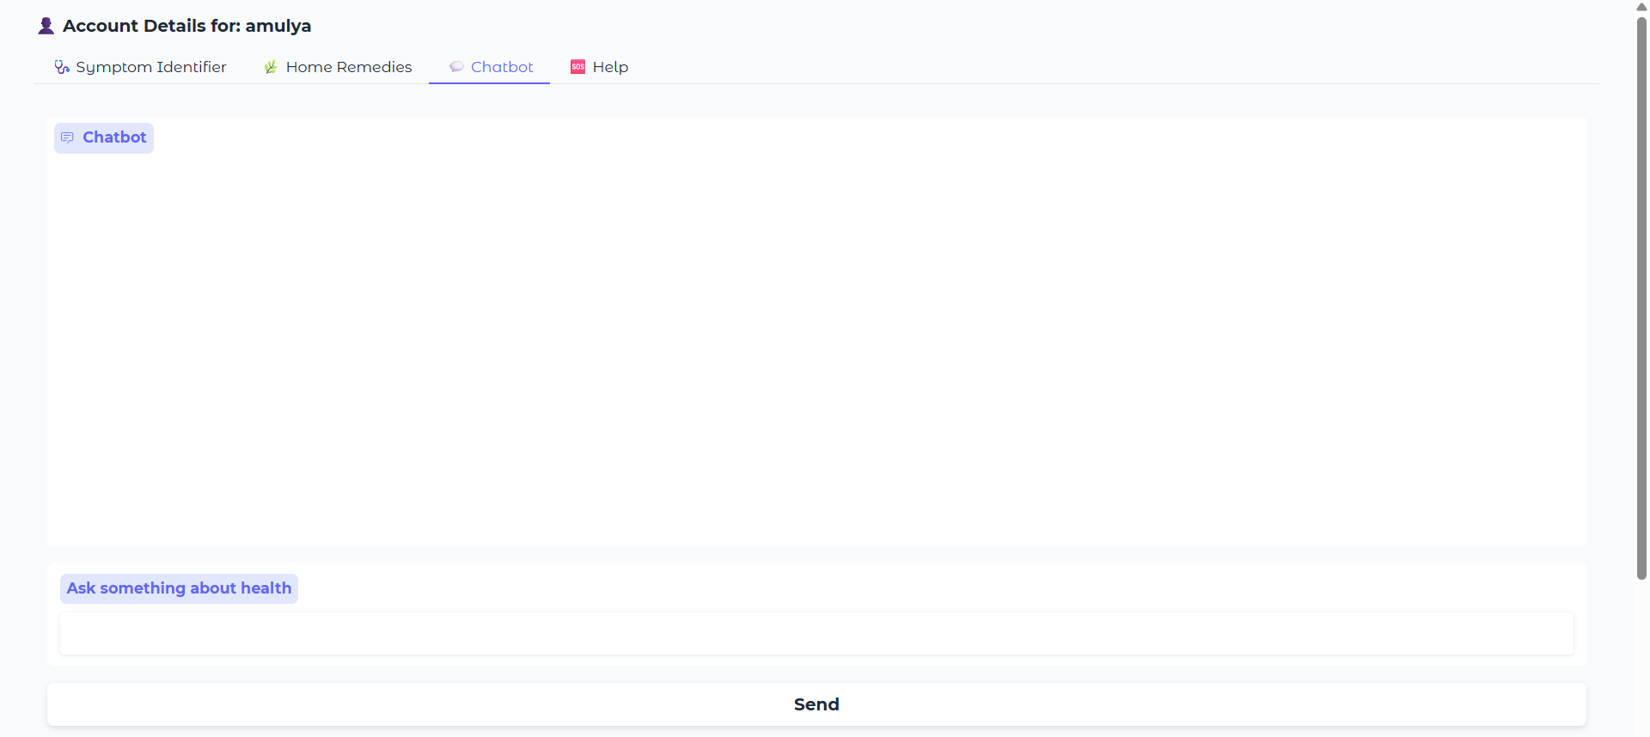

**Description:**The HealthBot Chat Assistant is an intelligent, conversational feature of Health AI designed to answer a wide range of health-related questions. Users can chat with the AI in natural language, asking about symptoms, remedies, healthy habits, or general medical advice. Powered by the IBM Granite AI model, the chatbot responds instantly with clear, informative answers, creating a helpful and engaging user experience. It’s like having a virtual health assistant available anytime. While it doesn’t replace professional medical consultation, it offers quick support and guidance for everyday health concerns.

**Patient chat output:**

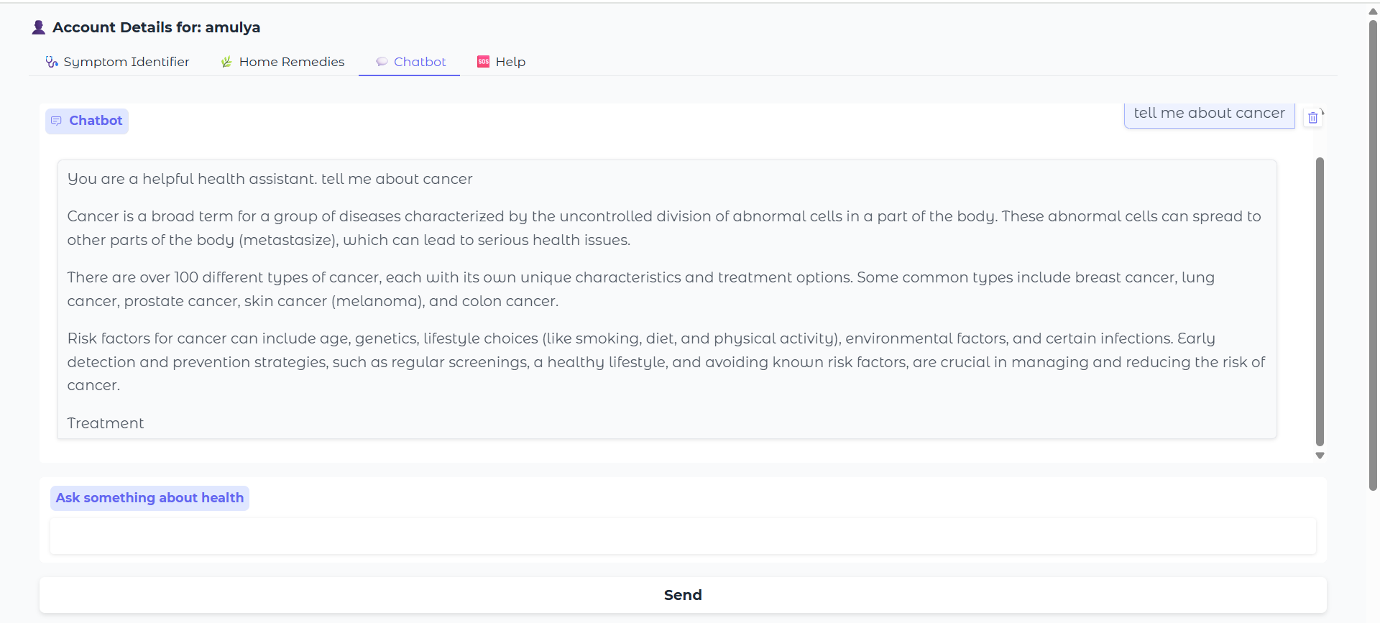

**Help page:**

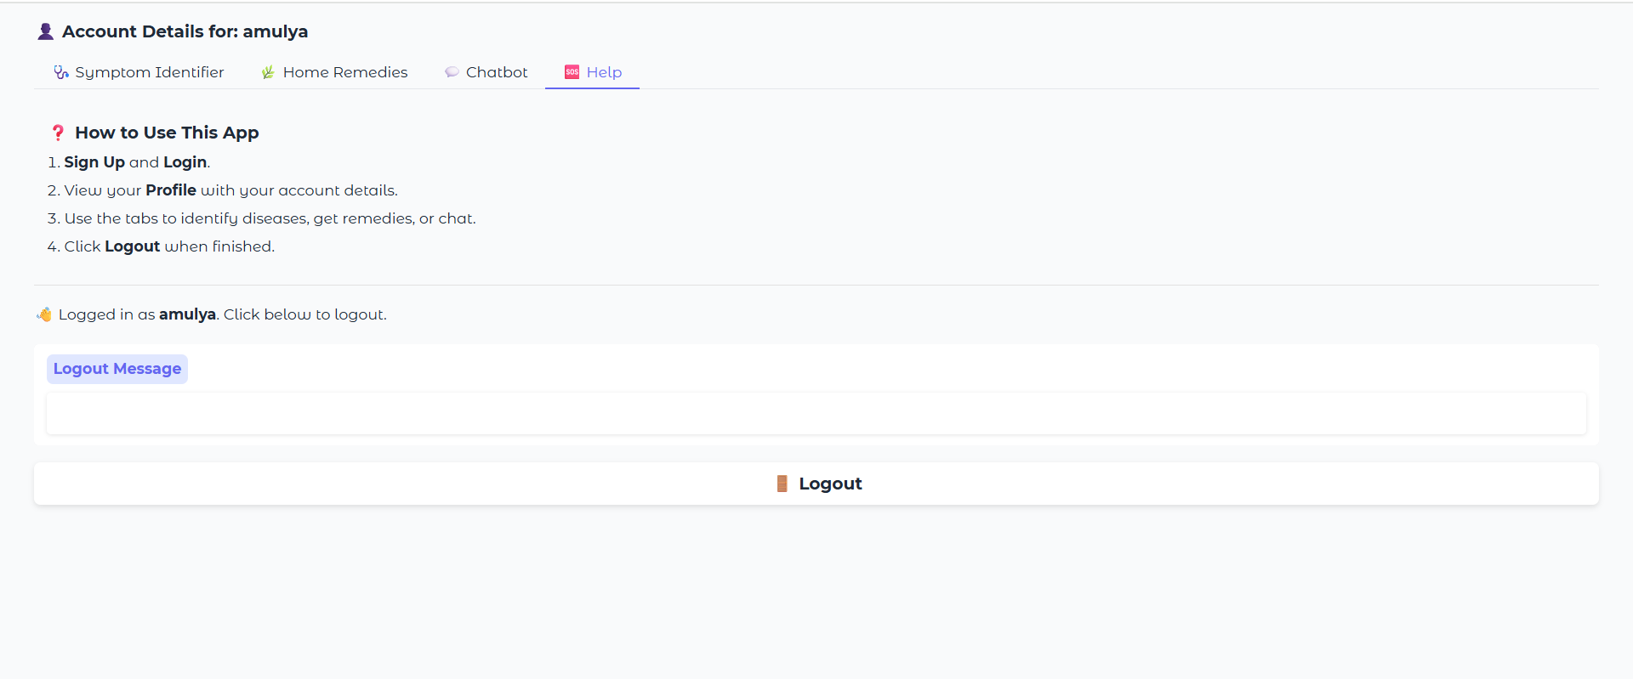

**Description:**The Help section of Health AI serves as a quick and easy guide for users to understand how to use the application effectively. It provides clear instructions on signing up, logging in, using the symptom identifier, exploring home remedies, and chatting with the HealthBot. This section ensures that even first-time users can navigate the platform with confidence. Designed to be simple and informative, the Help tab enhances user experience by answering common questions and explaining each feature’s purpose. It acts as a built-in support system, available whenever users need guidance.

# 12. Known Issues

• Session resets on Colab refresh.

• Gradio link expires after a while.

• Image diagnosis not yet implemented.

# 13. Future Enhancements

• Deploy permanently via Hugging Face Spaces.

• Integrate real authentication and databases.

• Add image diagnosis via CNN.

• Support multilingual input and admin dashboard.